AEM TASK

# Apply Styling on Header & Footer:

To style the header and footer, use the AEM Style System and update CSS styles in the ui.frontend module.

Header:

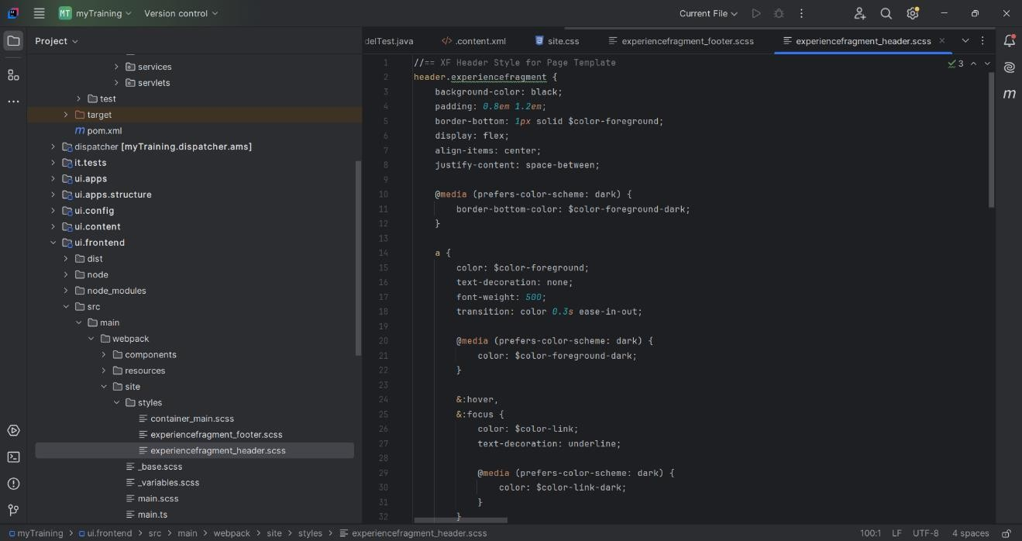

Footer:

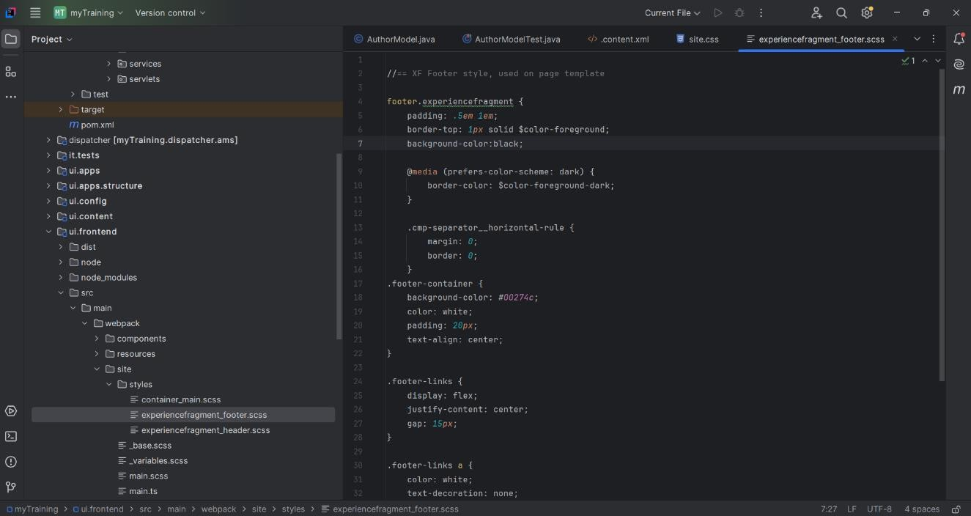

Header of Home Page:

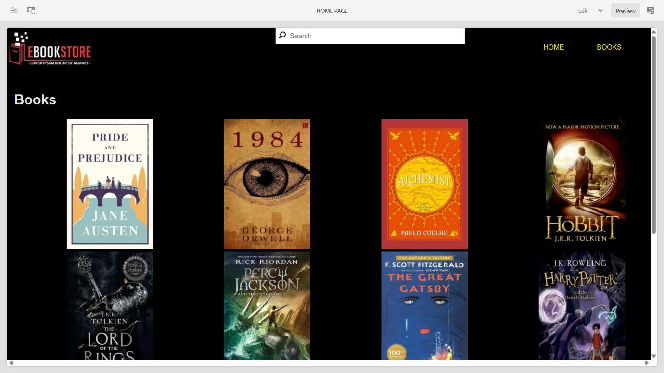

1. Custom Page Property

A new textarea property 'addScript' was added to the Book Page component, allowing authors to inject scripts dynamically.

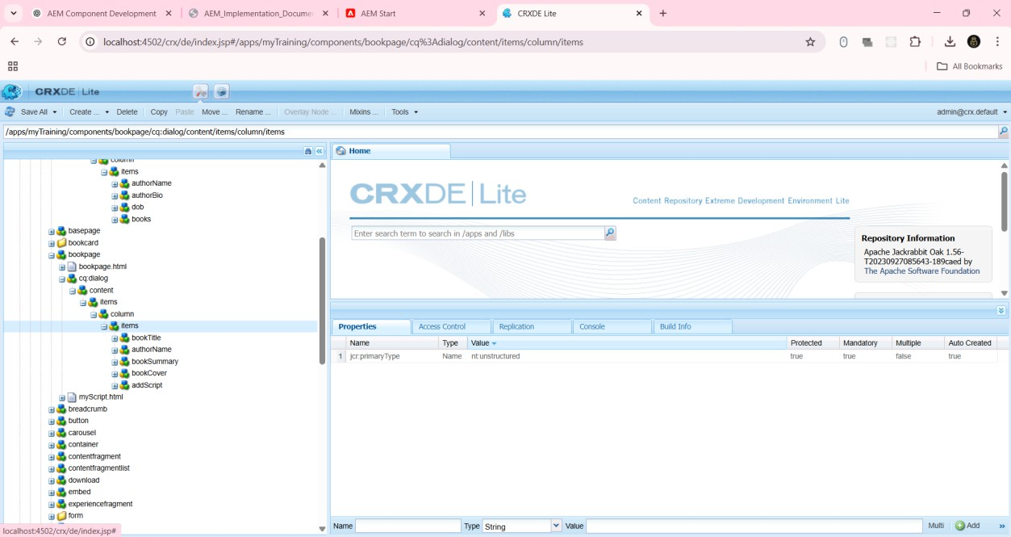

# Updates to Author Component :

A new text property and a multifield for books were added to the Author component. A Sling model was implemented to fetch these properties.

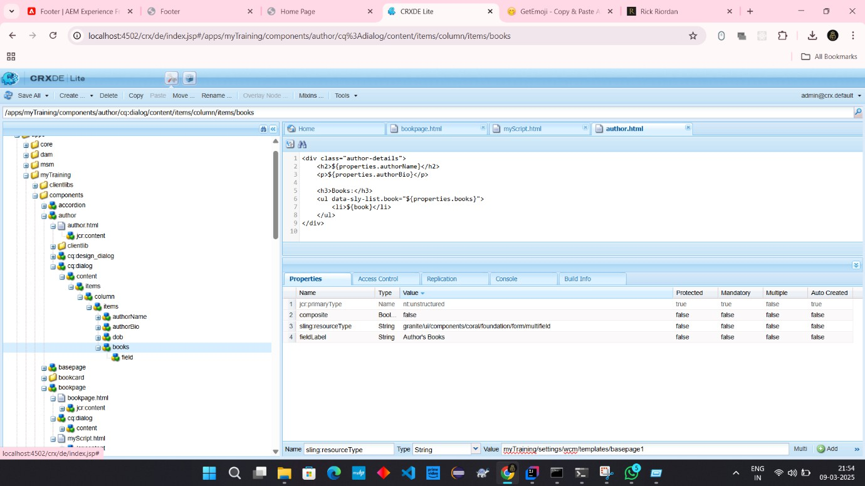

Author Details Component implemented by multifield

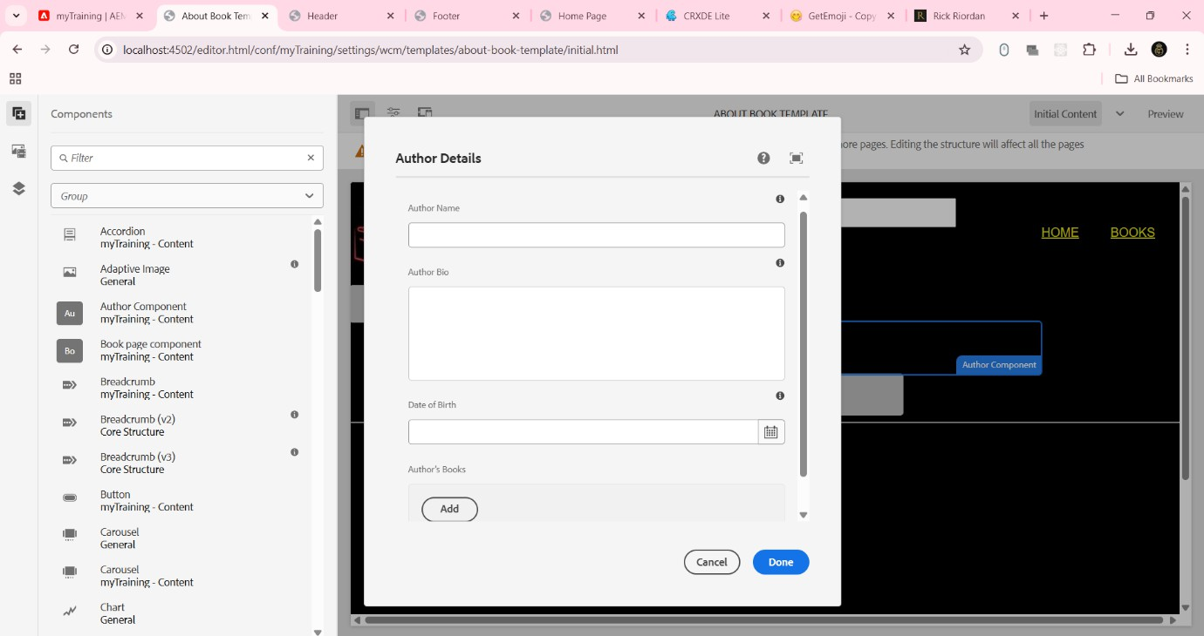

# Creating 'About Book Template' :

A new template was created using the base page template, enabling authors to generate book-related pages efficiently.

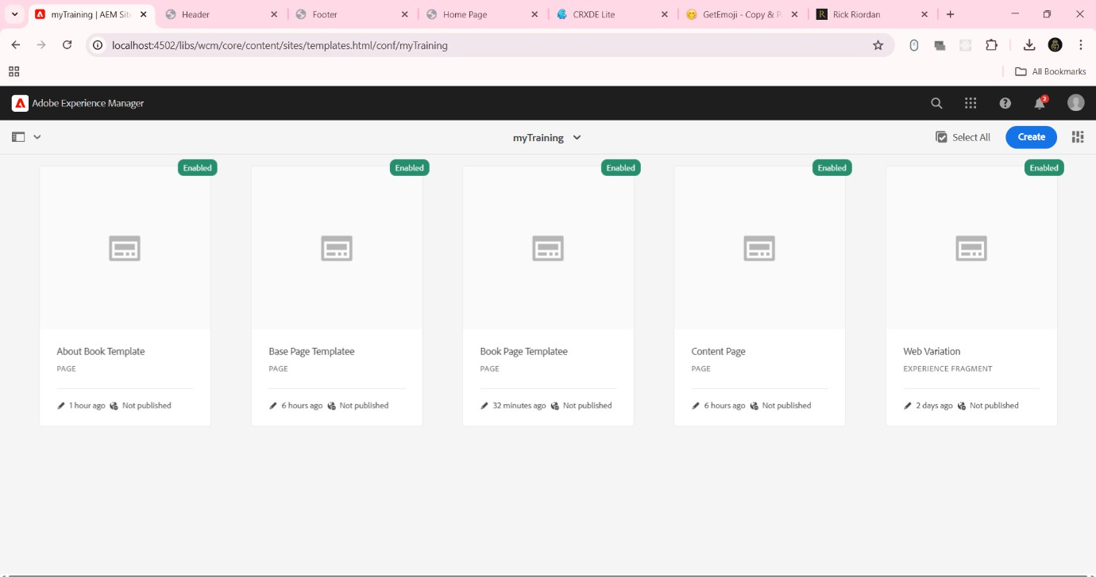

Book component template:

It contains the details of authors.

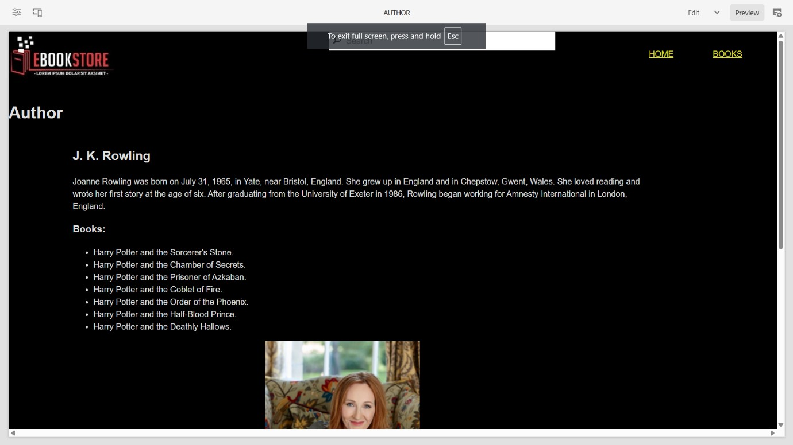

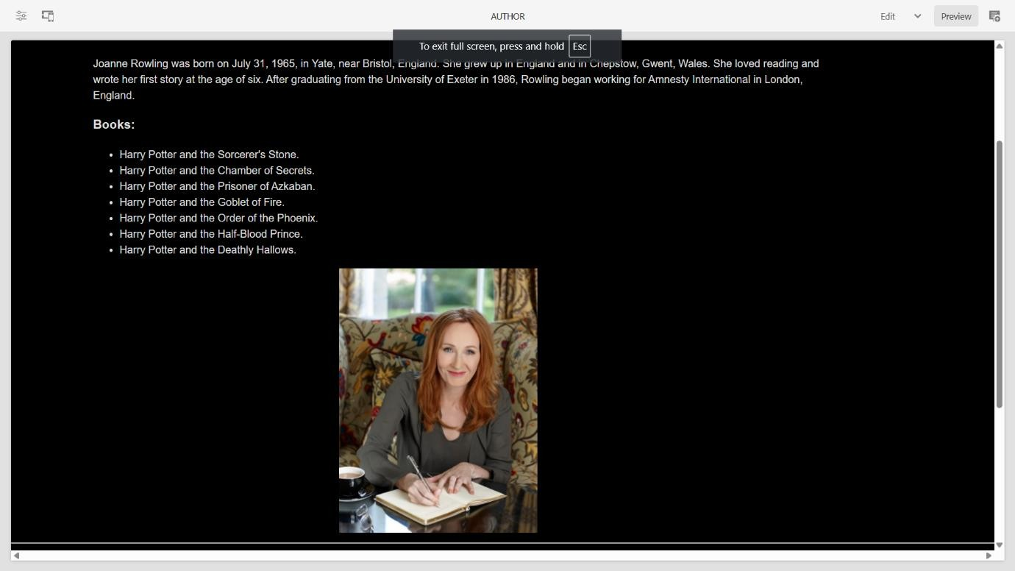

# Creating Book Page Component:

A Book Page component was developed, utilizing the base page template. It fetches properties and allows dynamic content addition.

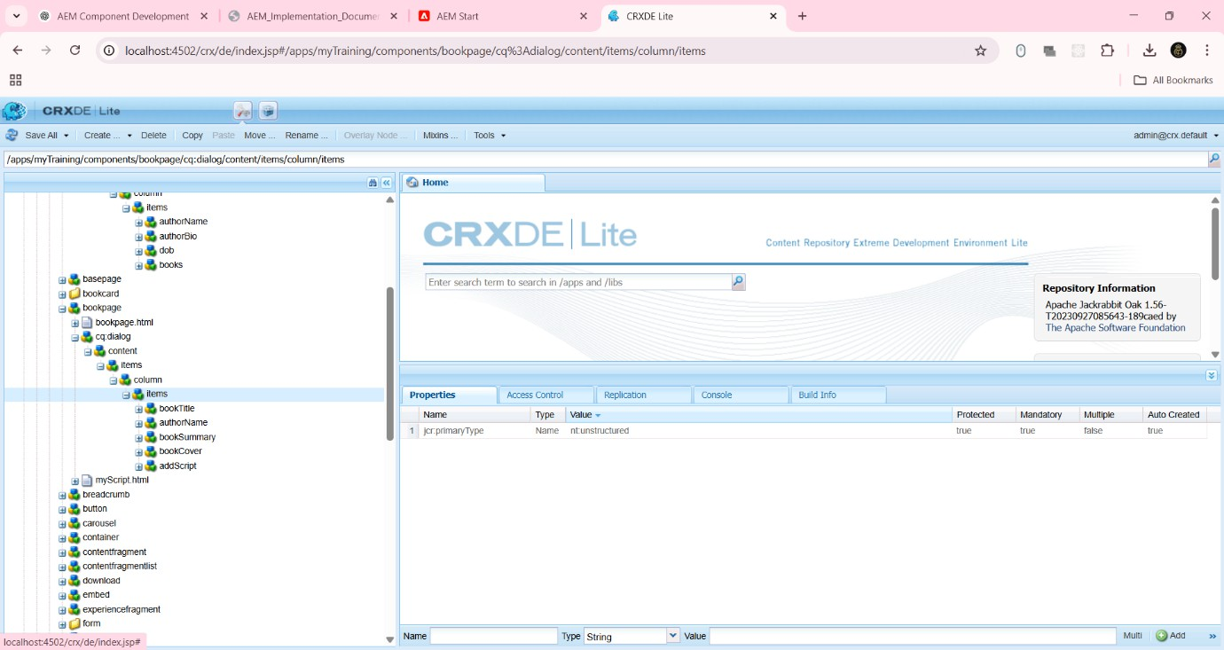

Configuring AuthorModel for accepting multifield inputs from user

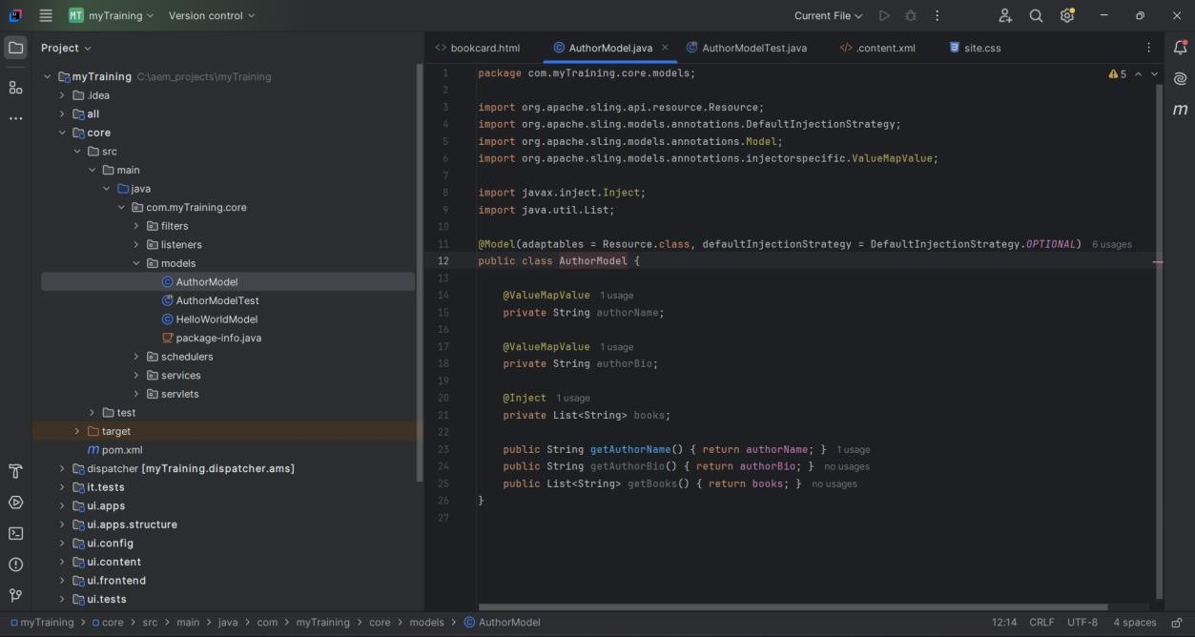

Home page:

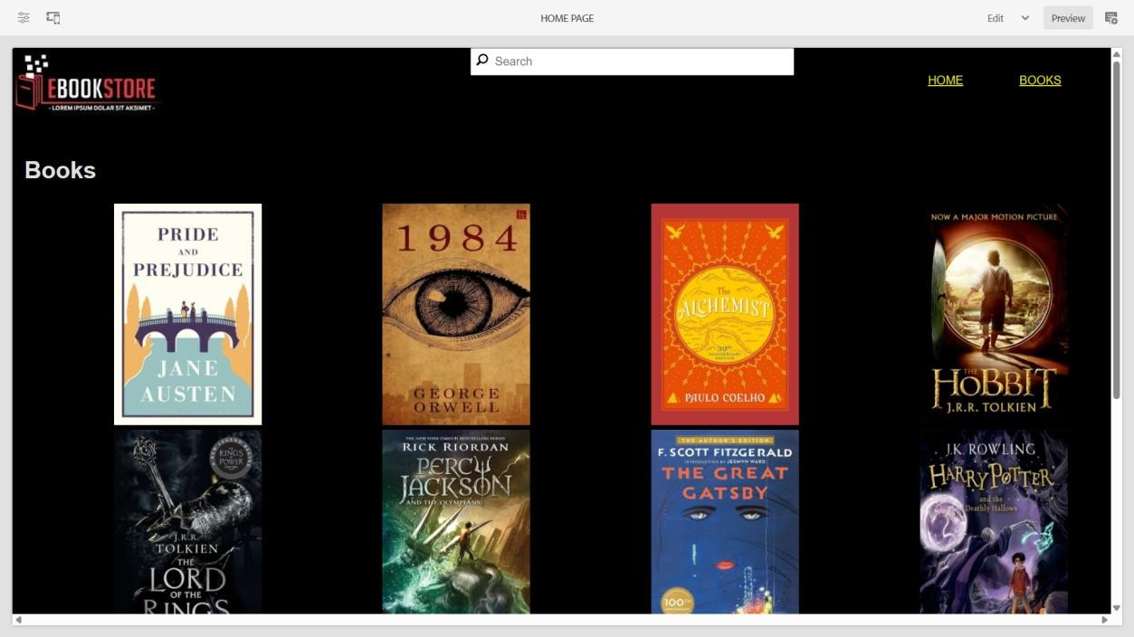

Books page:

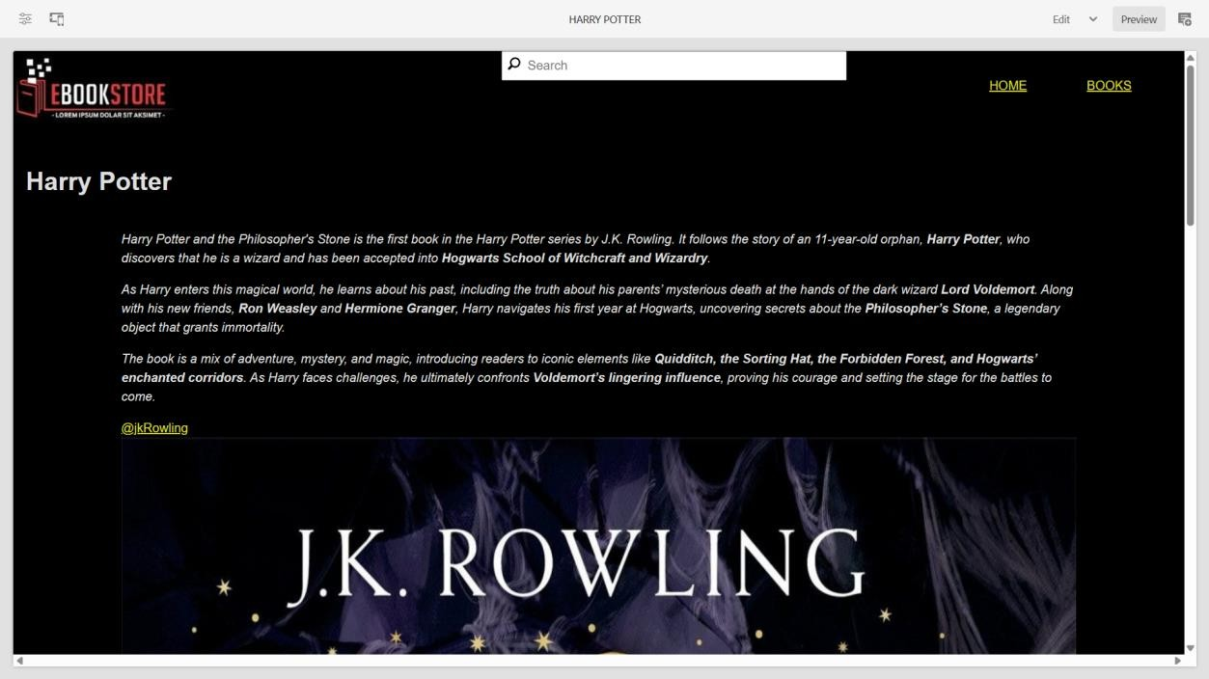

Author page:

